**Concento Rapid Data Governance**

**User Guide**

**Version 2.0**

Contents

Introduction to Concento RDG 1

Welcome to Concento™ Rapid Data Governance 1

About this Guide 1

Concento™ RDG Architecture 1

Prerequisites 1

Initial Setup and Configuration 2

Licensing of This Product 2

Concento™ RDG User Interface 2

Home Screen 2

Menu Structure 3

Concento™ RDG Design 3

Users and Roles in RDG Design 3

Concento™ RDG Navigation 4

Manage Data Model 5

Create Data Model 5

Create Entity 6

Create Attributes 7

Create Type 4 Entity, Child Entity 9

Create Qualifying Entity 10

Manage MDG Workflow 12

Create a CR Type 12

Create a Workflow – 1 Level of Approval 14

Add Parallel Flow 16

Adding Dynamic Rules 17

Manage Business Rules 20

Mandatory Business Rule 20

Value Check Rule 21

Multi-value Check Rule 24

Derivation Rule 25

Multi-value Derivation Rule 26

Field Property Configuration 27

Single Value UI Property 27

Multi Value UI Property 29

Interface Configuration 30

Create New Replication Model 30

New Business System 31

# Introduction to Concento RDG

## Welcome to Concento™ Rapid Data Governance

Concento™ Rapid Data Governance (RDG) is an SAP UI5 Cloud-based application that builds on SAP Business Technology Platform to automate MDG customizing and enhancement through standard APIs.  It provides an elegant UI and sensible logic to help users to perform all necessary tasks for a typical SAP MDG implementation.  It can also help to empower the business to maintain a deployed SAP MDG solution without the comprehensive technical background.

Through intuitive graphical representation of the data model, business rules and workflow Concento™ RDG increases the adoptability and usability of SAP MDG through an elegant UI. RDG can complement and fast track MDG reducing the cost of implementation by at least 30%.

## About this Guide

This guide contains two kinds of information:

An overview that helps you understand Concento™ RDG and how it works.

Step by step information that explains the process and how to perform all necessary tasks of a typical SAP MDG implementation in the RDG application.

# Concento™ RDG Architecture

# Prerequisites

HTML5/SAPUI5 Application running on SAP Business Technology Platform.

SAP MDG installed and activated.

On-Premise Extension Connected to SAP S/4HANA.

# Initial Setup and Configuration

Concento™ RDG runs as a website on the client's network. Authorized users on the client's domain have access to tools directly or the tools can be accessed remotely from a VPN connection. No other client software installations are required apart from a supported standard web browser such as Google Chrome, Mozilla Firefox or Microsoft Edge. Your local system administrator will provide you with the correct links, user ID and password to access Concento RDG.

## Licensing of This Product

Maintaining an active license for Concento™ RDG application suite is the responsibility of the project team administrator and client. The license will be valid per application installation server and each application will have its own license. To apply for a new license the project team administrator must submit LicenseKeyCollection.pdf form that can be downloaded from the DMR SharePoint site and submitted to the Development team for approval and build.

# Concento™ RDG User Interface

## Home Screen

After logging into Concento™ RDG, the user will see the RDG Home Screen as shown below. The Home page includes the graphical representation tiles for the Data Model, Workflow, Business Rules, Field Property UI and Interface Configuration. The home screen includes user interface (UI) controls including a Menu Bar and Sign-out options.

## Menu Structure

The Menu Structure includes different functional areas and the sign-out option.

The navigable areas of RDG include:

Manage Data Model

Manage MDG Workflow

Manage Business Rules

Field Property Configuration

Interface Configuration

# Concento™ RDG Design

## Users and Roles in RDG Design

|  |  |
| --- | --- |
| **Role** | **Definition** |
| Admin | Basis/Team Administrator responsible for all initial setup |
| R&D and Planning | The design Architects responsible for the product design and planning |
| Developers | The team responsible in the developing the product |

## Concento™ RDG Navigation

|  |  |  |
| --- | --- | --- |
| **Icon** | **Name** | **Use** |
|  | **Back** | **The back button helps to navigate to the previous screen or exit from the  current screen** |
|  | **Show Entries** | **The entries icon will present a list of entities that have been created under the selected data model** |
|  | **Add Entity** | **The + icon will open the screen to create a new data model** |
|  | **Check Data model** | **This icon will begin the check for any errors** |
|  | **Show messages** | **Checks and displays any warning messages at activation** |
|  | **Activate Data Model** | **To activate the data model after all the necessary changes have been made** |
|  | **Refresh View** | **Helps to refresh the page after activation** |
|  | **Edit** | **Edits the selected item** |
|  | **Create SMT** | **Initiates process to map from source table to target UI** |

# Manage Data Model

Concento RDG utilizes APIs to automate many steps that are required to extend a data model. RDG automates the entire process to create domain and elements through the executing of APIs. RDG derives all the necessary relationships when extending the data model with a custom entity and provides a relational model UI to visualize the data model to facilitate maintenance. With Concento RDG you can accomplish the extension with a wizard-based guide on a visualized view of the data model. After Data Model extension RDG enables SMT mapping to map new entities or attributes from the backend tables to the UI.

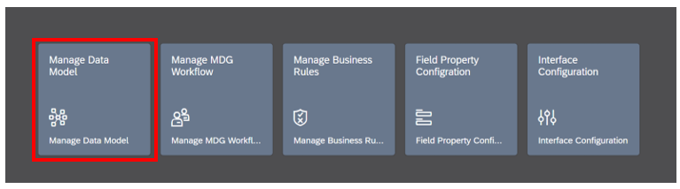

## Create Data Model

1. From the home screen, select ‘Manage Data Model’ and then click the  icon
2. Enter relevant information in green highlighted row:

Data Model – 2-character name beginning with a ‘Z’

Description – Description of the data model

Prefix/Namespace – Add the prefix

Package – Select a package from the drop-down







1. Select Icon

   Description automatically generated save and activate.
2. Select Transport, successful message should appear as shown.

## Create Entity

1. Highlight the Data Model you want to extend and select  show entities.
2. Expand the data model and highlight an entity. Select Add Entity  Enter Transport Request if prompted.



1. Every data model must have a Type 1 entity, select the Entity type radio button in the Entity Details screen and select next Graphical user interface, text, application

   Description automatically generated and enter entity details:

Entity Name – Name of entity

Description – Description of the entity

Package – Select a package from the drop-down

Additional fields are defaulted:

Storage / Use Type – Changeable via CR (for all Type 1 entities) and disabled from further selection.

Is Entity Key – Type 1 entity is the head entity and disabled from further selection.

Validity/Entity – No Edition, applicable for FI domain and data models only

Key Assignment

Data Element – is blank and disabled, not applicable for Type 1 entities.

Is Hierarchy Type, Validity/Hierarchy & Field Cardinality – NA for Type 1 entities.

(Type 1 Entity Additional) allows the optional entry of entity level details.

## Create Attributes

to display the Attribute or Key Attribute section on the UI

1. Enter attribute details:

Attribute – Key Attribute or additional attributes begin with a ‘Z’

Description – Description of attribute

Data Element - Data Element can be a data element from an SAP table or a custom data element to be used for processing in MDG.

If the data element does not exist, enter the data to create:

Package

Data Type

Character Length

1. Select next Graphical user interface, text, application

   Description automatically generated to enter additional details for that key attribute (optional)

1. Click next Graphical user interface, text, application

   Description automatically generatedto create other attributes and additional data for the entity if necessary.

1. Select a transport request if prompted to store the changes.
2. Add additional attributes by selecting  on the bottom right of the UI.
3. To finish adding Type 1 Entity, Key Attribute and Attributes select  on the bottom right of the page.

The Data Model Entity Tree will display the new Type 1 Entity, Key Attribute and Attributes.

1. Select  to validate the data model for errors.
2. Select A picture containing text, monitor, close

   Description automatically generated to activate the data model and generate structures.

## Create Type 4 Entity, Child Entity

Once a Type 1 Entity has been created in the data model the following process can be used to create a Type 4 Entity.

1. Selecting the  button on the Data Model Entity Tree screen will provide options of adding a Type 4 Entity, Referencing Entity or Attribute under the Type 1 Entity.

1. Select Type 4 Entity. RDG automatically populates the following fields per the properties of a Type 4 Entity:

Storage/Use Type – Changeable via Other Entity Type

Is Entity Key – Child Entity

Key Assignment – Key Cannot Be Changed

1. Populate details for the Type 4 Entity:

Entity Name – Name of entity

Description – Description of the entity

Package – Select a package from the drop-down

1. Click next Graphical user interface, text, application

   Description automatically generatedto add additional data for Entity if necessary and to create qualifying entity.

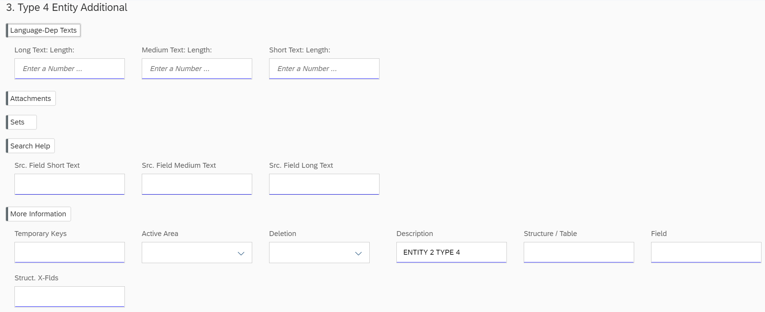

## Create Qualifying Entity

1. For Qualifying Entity complete the following:

Entity Name - Select Main Entity Name

Additional data will default.

Field Cardinality may be selected if default 1:N is not desired

1. Click next Graphical user interface, text, application

   Description automatically generatedto add additional data for the entity if necessary or additional attributes.
2. Save all the changes to the TR, check for the errors and then activate the data model.  .

Once the activation is completed, refresh the page for the changes to appear.

## SMT Mapping

When new updates to the Data Model have been activated, you will need to select a package and a prompt for SMT mapping will display.

1. Select and map each line:

Mapping Step – BUS_EI_BUPA_CENTRAL_DATA/ MDG_BS_BP_BP_CENTRAL

Structure to extend – CI_EEW_BUT000

Source and Target will automatically populate based on selection of Mapping Step

1. Select A picture containing text, display, screenshot

   Description automatically generated to initiate SMT mapping for each line

Once mapping is complete a Success Status will be displayed

1. When you have successfully completed the mapping select  and a confirmation pop-up will appear as a warning to close the mapping window. Select Graphical user interface

   Description automatically generated with medium confidence to complete.

# Manage MDG Workflow

Concento RDG provides the solution to bridge the gap with a visualization of the BRF+ workflow into an intuitive graphical format. The application allows the users to easily maintain the workflow on the UI which will in turn translate to BRF+ table through APIs. Concento RDG also enables users to maintain and create Change Request Type and to maintain workflow for the change request type in the same UI.

Depending on business needs, Concento RDG allows users to implement Dynamic and Parallel steps for complex workflow scenarios eliminating the tedious steps of workflow maintenance followed in a traditional approach.

## Create a CR Type

1. From the home screen, select ‘Manage MDG Workflow’ and then click the icon

1. Enter the required details and select Save:

CR Type

Description

Data Model

Main Entity

Business Activity

Leading Entities will default from Main Entity

1. Select transport request:

1. A successful message should appear. Select Graphical user interface

   Description automatically generated with medium confidence and a standard workflow will be populated as shown.

## Create a Workflow – 1 Level of Approval

1. Select Add Icon

   Description automatically generated option by clicking on the Requestor. Graphical user interface, application

   Description automatically generated
2. Select the add approver option  and TR to add the necessary workflow approver details and save:

Approver Type

Approver

Step Type

Step Actions will default from Step Type

1. Select Edit connection Icon

   Description automatically generatedby clicking on the Approver Diagram

   Description automatically generatedadd the necessary Action Targets details as below and Save.

1. Select  to validate the workflow. A validation message should appear:

1. Save to complete the workflow and create BRF tables.

1. Repeat the steps above for additional approval levels as needed.

Depending on business needs, Concento RDG allows users to implement Dynamic and Parallel steps for complex workflow scenarios eliminating the tedious steps of workflow maintenance followed in a traditional approach. With RDG, users having no prior experience in BRF+ application, Decision Tables and ABAP programming can easily handle the steps included in the guide as RDG automates the entire implementation of BAdIs and rule-based workflow in BRF+ to handle Dynamic and Parallel workflow steps in a simple UI Screen.

### Add Parallel Flow

1. From the Change Request select the workflow position and Parallel Flow Logo

   Description automatically generated with medium confidence

1. Add Attribute  to be used for the Parallel workflow
2. Select Add Rule Graphical user interface, application, website

   Description automatically generatedhighlight and enter details for rule:

Attribute value

Approver Type

Approver

Step Type

For a Parallel workflow Scenario, when all company codes are to be approved by its corresponding owners, we choose company code as attribute from the entity BP_CUS_CC and give list of company codes for which the approvals are necessary. Workflow requests will be sent to all the approvers parallelly.

### Adding Dynamic Rules

1. From the Change Request select the workflow position and Dynamic Rules Logo

   Description automatically generated

1. Add Attribute  to be used for the Dynamic Rule
2. Select Add Rule Graphical user interface, application, website

   Description automatically generatedhighlight and enter details for rule:

Attribute value

Approver Type

Approver

Step Type

In a Dynamic Rule scenario the request is routed dynamically based on the values set with the rule.

1. Once the workflows are saved, BRF decision tables are created and populated automatically for rule-based workflow with parallel and dynamic steps.

Decision tables are populated for Rule Based Workflow allowing maintenance even for complex scenarios in RDG with no prior knowledge in ABAP, BRF+ configuration and BAdI implementations.

1. To complete workflow select the node and edit connections Icon

   Description automatically generated to open Action Targets
2. Complete the appropriate Action details for all workflow steps:

Target State

Status

1. Select  to validate the workflow. A validation message should appear:
2. Save to complete the workflow and create BRF tables.

Decision tables are populated for Rule Based Workflow.

# Manage Business Rules

Concento RDG provides breakthrough technology to bridge the gap to the known BRF+ MDG limitation to allow cross-entity checks and enrichment in Business Rule Management. Concento RDG provides simple UI control for users to maintain Business rules, automating configuration steps and executing APIs to create them as BRF+ rules in the MDG system.

## 

## Mandatory Business Rule

1. From the home screen, select ‘Manage Business Rules’ and then select the Change Request type and the Entity.
2. Select Mandatory Rule  from the dropdown next to the entity.

Scroll to the top of the page if you are not able to view the drop down rule menu.

1. Select the attribute to set as Mandatory.



1. Select the appropriate TR for the change and make the attribute to mandatory.

1. BRF+ application will be updated with the Rule created.

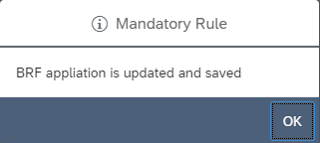

## Value Check Rule

RDG provides the flexibility to apply the business rules with the appropriate messages if conditions do not meet the business rule.

1. Select the dropdown next to the entity and select the value check rule.

It is necessary to build a Value Check Rule for certain Type 4 Entities which share the UI with Type 1 Entities.

1. Select the attribute for the value check and the expression

1. Select generate flow Icon

   Description automatically generated
2. Complete the conditions using values or attributes:

If AD_POSTAL-REF_POSTA = “CN”

Or AD_POSTAL = “IN”

Then display error message “COUNTRY IS INVALID” for All workflow steps

1. Select the workflow step determining when the rule will be enforced.
2. Select the message type details (A preconfigured message class and text or custom message can be used).

1. Save and select the TR.
2. The rule is created in the BRF application and a successful message should appear:Background pattern

   Description automatically generated with medium confidence

## Multi-value Check Rule

Multi validation Rule allows us to create the multiple business rules by adding validating attributes with the appropriate messages if conditions do not meet the business rule.

Additionally, it allows us to Delete a single Rule from the list of rules or delete rules in their entirety.

1. Select the dropdown next to the entity and select the Multi-Value Check Rule.

1. Add the validating Attributes Text

   Description automatically generatedfor the multi value check
2. Select Add Rule 
3. Highlight the new line to enter the rule data.
4. Enter Rule Details for:

Validating Attributes

Workflow Step

Message Type

Message Class

Message Number

1. Save the Rule.Configuration, select TR and Package. Successful message should appear:

## Derivation Rule

RDG Derivation Rule enables the derivation of a single value based on the business conditions (check expressions in the below screen) for the driving attribute values between the entities.

1. Select the dropdown next to the entity and select the Derivation rule.
2. Select the attribute for the derivation and the expression

1. Select generate flow Icon

   Description automatically generated
2. Complete the conditions using values or attributes:

If AD_POSTAL-REF-POSTA = “US”

And AD_POSTAL-CITY1 = “DENVER”

Then derive the attribute value AD_POSTAL-POST-COD1 = “80014” only for Initial processing step

1. Save the Rule.Configuration, select TR and Package. Successful message should appear.

Begin to type the value you are searching for to view additional selections in the menus.

## Multi-value Derivation Rule

Allows the addition of multiple derivation rules based on the conditions of the driving attribute values.

1. Select the dropdown next to the entity (The entity which contains the attribute you are deriving) and select the Multivalue Derivation.
2. Add the Deriving Attribute Graphical user interface, text

   Description automatically generated
3. Add the Driving Attributes Text

   Description automatically generated

If these are in a different entity select Cross Entity Derivation and determine whether or not dependent key entries are needed.

1. Select Add Rule 
2. Highlight the new line to enter the rule data.
3. Enter Rule Details for:

Driving Attributes

Workflow Step

Deriving Attribute

1. Save Configuration, select TR and Package. Successful message should appear.

# Field Property Configuration

Concento RDG eases the process of creating a change in any of the fields in the UI displayed, by automating the configuration steps as shown below. The user interface is designed for everyone to effortlessly navigate around to create the rules required. To change the property of a field for a specific Change Request Type you can use either a Single Value UI Property or a Multi Value UI Property.

## Single Value UI Property

Used to set one field property. In the drop down, select Single Value Field Property.

1. In the home screen, select ‘Field Property Configuration’
2. Select the specific Change Request Type for which the enhancement must be applied.
3. After selecting the Change Request Type, select or search for the Entity which contains the fields for the UI properties update.
4. Select ‘Single Value Field Property’
5. Enter the Attribute and select the relevant expressionGraphical user interface

   Description automatically generated

You will then see a list of options to choose from. The 4 options in the UI Property drop down are:

C – Optional

R – Read Access Only

M – Required Field

H – Hidden Field

1. Select one of these options for the corresponding workflow step for the CR Type selected previously. In the example, for the attribute Region to be mandatory, the country value must be IN or US.

1. When you click on Save, you are prompted with the Transport Request List. Select your TR. Followed by selecting a Package.

 A Successful message should appear. The Field Property is now configured and will be listed in the tab.

## **Multi Value UI Property**

Used to set multiple properties at once. In the drop down, select Multi Value Field Property.

1. In the home screen, select ‘Field Property Configuration’
2. Select the specific Change Request Type for which the enhancement must be applied.
3. After selecting the Change Request Type, select or search for the Entity which contains the fields for the UI properties update.
4. Select ‘Multi Value Field Property’
5. Add Deriving Attribute – The attribute which changes based on the Driving Attribute.
6. Add Driving Attribute – The attribute which is to be matched against a value or check to determine the property of the Deriving Attribute.
7. Select ‘Add rule’ to add multiple values.
8. Enter each value as a different rule, where each Field Property setting is for the Deriving Entity. If it is to be applied for only one part of the workflow step, select the steps under WF – STEP column, or else ** – for every WF step.
9. Select the Property options.

1. **Select save, then** the TR and Package.Table

   Description automatically generated

The Rule will be created and displayed under Multi UI Property

# Interface Configuration

Concento RDG eases the process of creating and mapping interfaces by automating configuration steps and simplifying the process onto one easy to navigate screen. New business systems can be added, and mapping completed while easily visible to the users. RFC connections must first be established in SAP to complete the interface process.

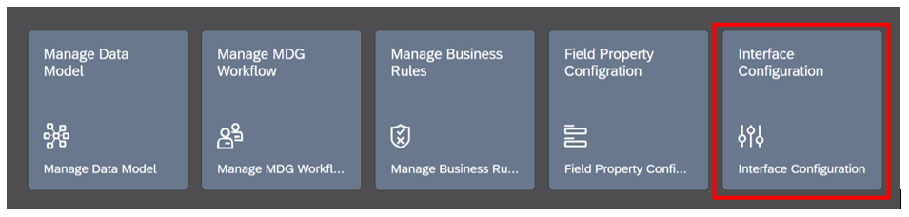

## **Create New Replication Model**

1. In the home screen, select ‘Interface Configuration’
2. Create new Interface by selecting 
3. Enter required data:

Replication Model – ZCUST003 *(select or create new)*

Description – CUSTOMER REPLICATION TO 003

Outbound Implementation – 159_2 – CMD *(select from existing connections)*

Communication Channel – Defaults from Outbound Implementation setup

Business System – ER9CLNT003 *(select from available systems or add new – see below)*

Additional data is optional:

Data Model

Sequence – Defaults to 00

Filter Time

If the Business System is not set up it can be added.

### 

### New Business System

1. Select Manage Business System to add a New Business SystemRectangle

   Description automatically generated with medium confidence
2. Enter required data:

Business System – follow standard naming convention

Additional data is optional

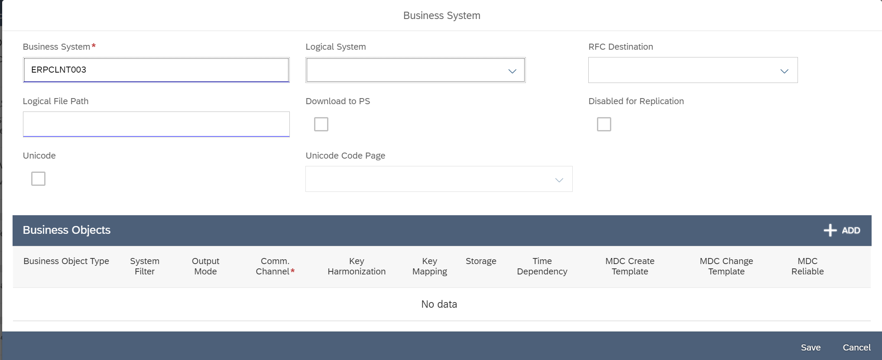

1. Select transport and save new interface.

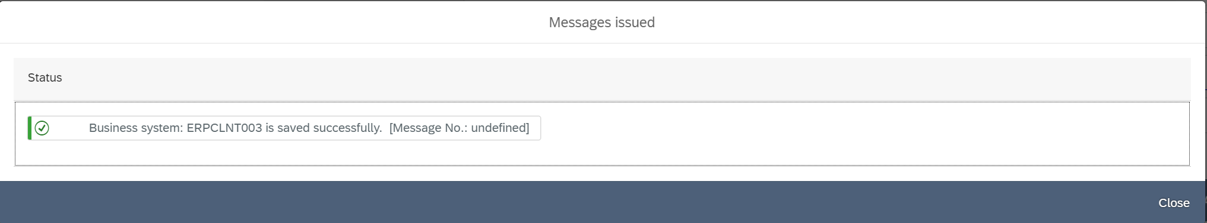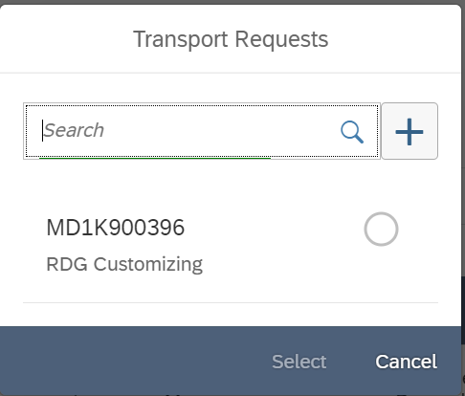

### New Mapping

1. Select the system for Mapping:

1. After selecting the Business System ensure the mapping is editable by selecting Edit Mapping:

1. Adjust the mapping accordingly selecting fixed, bypass or transformation:

1. Complete the mapping according to the transformation:

* If Fixed value is selected, enter the fixed value.
* Bypass will not require additional information
* Mapped value will require a referencing table to be selected along with the key then map it with the table field.

1. Graphical user interface, application

   Description automatically generatedSave mapping, select transport and package to complete.

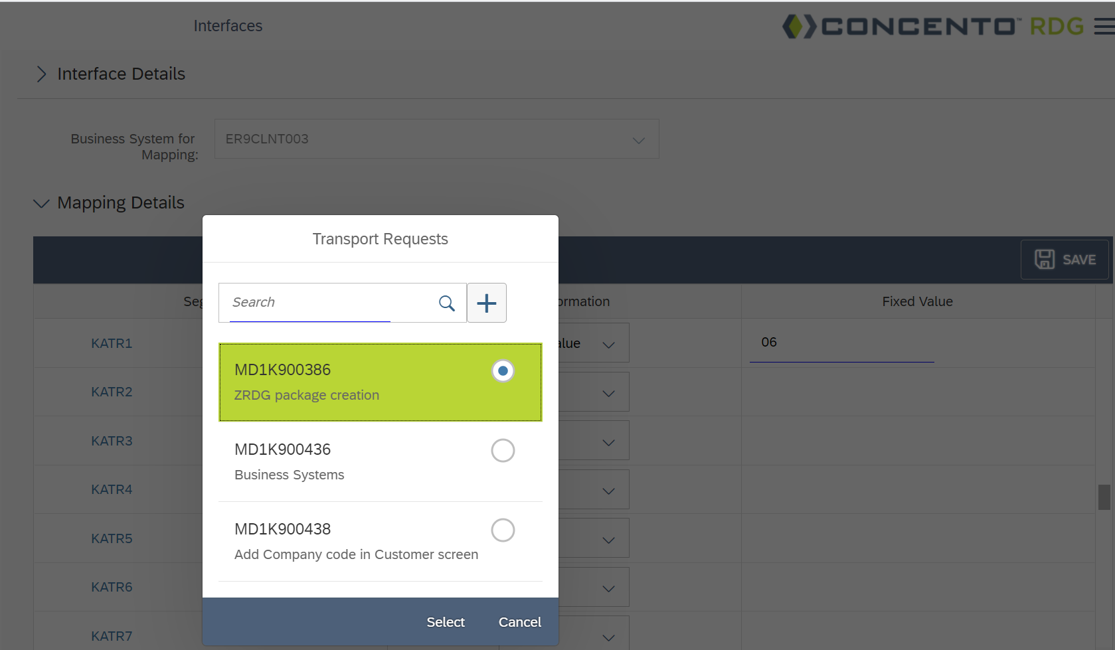

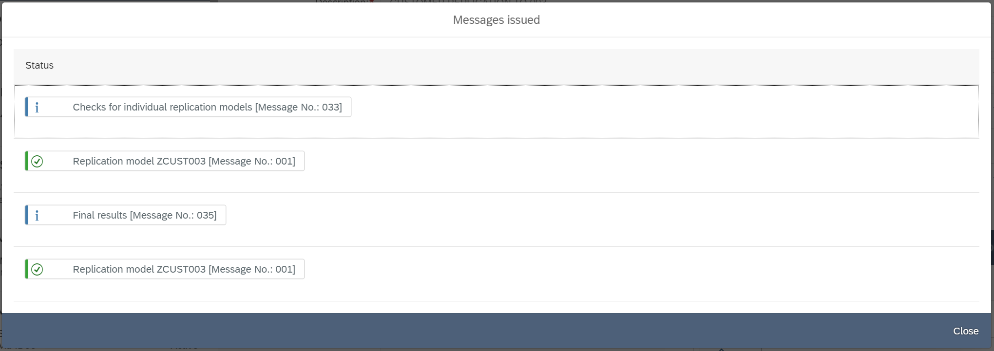

### Edit IDOC

1. **If an extension is not added to the standard IDOC type, then it can be added by selecting Edit Idoc**  A picture containing text, device

   Description automatically generated

*(User will now be able to create a new extension, copy from an existing or add a successor to an existing extension)*

* 1. Highlight the segment and click on Edit IDOC and then click on Add Extension.

1.2 Users now can create a new extension, copy from an existing one or add a successor.

1.2.1 To create an extension select New/Copy/Successor

* Add the extension name starting with “Z” (in case of copy and successor, choose the referencing segment from the list populated only in case of copy and successor)
* Give the description,
* The basic type (Basic IDOC Type) is defaulted already.

* Click on step 3
* Choose the parent Segment from the list
* Give the name of the segment starting with “Z”
* Choose a relevant referencing table
* Minimum and maximum can be set per requirements
* Add the fields to the segment
* Click on save once done adding all the required information and select the correct TR and package on the next step.

1. **If the IDOC type already has an existing extension, then user will only see options to add/edit segments**

(Segments must be added to a parent not custom segments, multiple segments can be added and only custom segments can be edited not the standard ones)



* 1. **Adding a segment**
* Highlight the parent segment (custom segments can only be added to parent segment) and click on the add segment

* Give the name of the segment starting with “Z”
* Choose a relevant referencing table
* Minimum and maximum can be set per requirements
* Add the fields to the segment
* Click on save once done adding all the required information and select the correct TR and package on the next step.

* 1. **Editing a Segment**
* The step1 and step 2 are already defaulted with information. Click on Step 3.
* User can change the reference table, “Maximum and Minimum”, can add/delete fields to the segment
* Click on save once done adding all the required information and select the correct TR and package on the next step.

Note: Cannot delete the interface/extension currently in RDG.