Metadata Scanning

Memory Allocation Issue Analysis

# Overview

This document details the steps required to analyse the reasons why the metadata scanning may have failed due to memory allocation issues at either the System, User or Work Process level on the SAP application. This will provide the information we need to advise the customer as to which parameters need to be changed to accommodate the scanning process.

# Process

1. Transaction Code: STAD  
   Apply the filters relevant to the metadata scanning process on the search for end time tab. These will be:  
   User = <user specified in the SAP Application Connection in the SKP>  
   Client = <client being scanned>  
   Program = ‘RFC’  
   Date = <date of scan>  
   Time = <start time of scan, based on SAP system time>  
   Length = <period of time the scan ran or longer>

Download the results of the scan logs to excel so that peak memory usage can be calculated and timings. Drill into the record with the max transferred kb value (last column) by double clicking on the record. E.g. 3rd record in the screen shot below.  
   


On the new detail screen scroll down and take a screen capture of the values shown in the following screenshot. Note the Max Extended Memory Used values.

1. Transaction Code: ST22  
   Choose Today or Yesterday depending on when the scanning error occurred and identify the record in question (example below with the Error TSV_TNEW_PAGE_ALLOC_FAILED).  
   A screenshot of a computer

   Description automatically generated

Double click on the error record and then choose the Local File button at the top left and locate the zip file for sending in to support that details the specific issue and memory parameters at the time of the issue.  
  
Identify the Work Process Number value in the above file or screen by scrolling down to the System environment section. In the example below it is 5, and we will need this in the next transaction.

1. Transaction Code: SM50  
   Select the record number that matches the Work Process Number above and choose Administration – Trace – Display File - Current  
   A screenshot of a computer

   Description automatically generated  
     
   On the page that displays run a find and specify the time of the issue when the scan threw the memory error to see the detailed message.  
     
   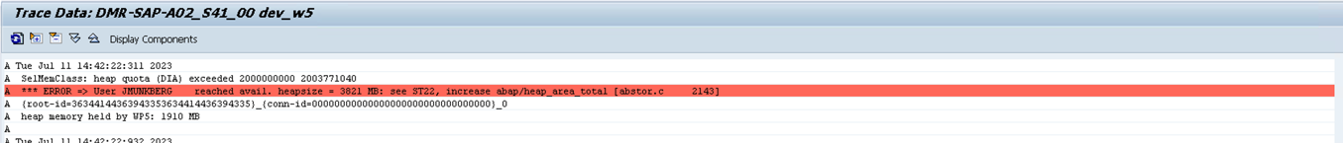  
     
   Take a screenshot of the message to share with support.Transaction Code: ST02  
   On the main page click on the Current Parameters button (top left). Scroll down on the resulting page and screenshot the memory settings at the bottom of the page.  
   A screenshot of a computer

   Description automatically generated
2. Transaction Code: SE38  
   Enter RSMEMORY in the program name and click the execute button. Take a screenshot of the resulting screen.A screenshot of a computer

   Description automatically generated
3. Transaction Code: RZ11  
   Enter ‘PHYS_MEMSIZE’ and click Display. Take a screenshot of the resulting page (example below).  
     
   A screenshot of a computer

   Description automatically generated

Return to the main RZ11 initial page and enter ‘ztta/roll_extension’ and click Display. Take a screenshot of the resulting page (example below).  
  
